* Core game loop:

Tap the sub to change direction/fire torpedo

Hit the opponent to gain the advantage/higher score

Use advantage to try and win the game

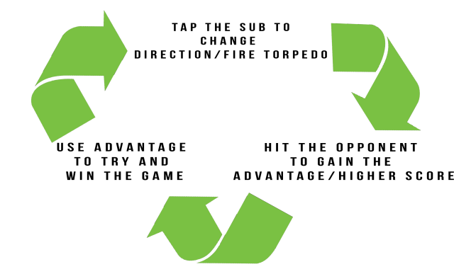

* positive feedback loop:

Player hits opponent with torpedo

Player now moves slightly fast being able to avoid torpedoes easier

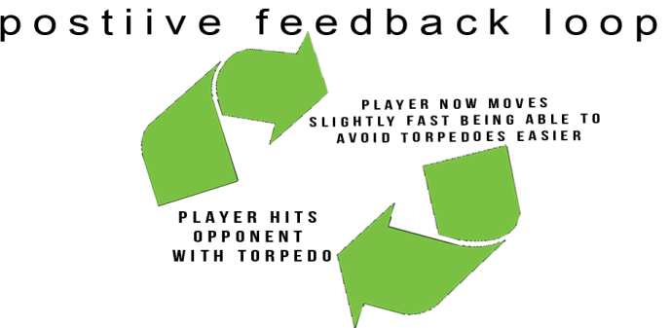

* negative feedback loop:

Player hits opponent with torpedo

Player that hit the opponent now has a cooldown before he can launch another torpedo

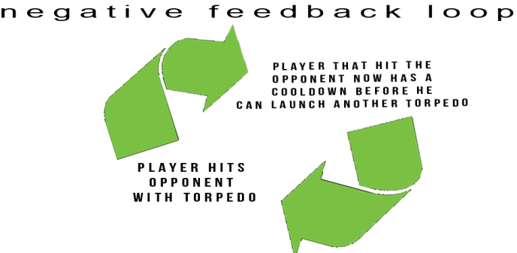

# Bibliography

Hall, B. (2013). *The Core Gaming Loop in Mobile and Social Games.*Available: http://www.benhallbenhall.com/2013/10/core-gaming-loop-mobile-social-games/. Last accessed 18th feb 2018.

Canvas. (2013). *Level 4.4: Feedback Loops.* Available: https://learn.canvas.net/courses/3/pages/level-4-dot-4-feedback-loops. Last accessed 18th feb 2018.

Allan, R. (2015). *Core loop: the must have feature for every mobile app.* Available: http://carnival.io/mobile-insights/core-loop-why-missing-it-can-mean-mobile-app-failure/. Last accessed 18th feb 2018

Gual, R. (2010). *Game Design: Positive and Negative Feedback; Flow Control.* Available: Randy Gaul's Game Programming Blog. Last accessed 18th feb 2018.

Reinink, B. (2016). *In-game economics: Feedback loops.* Available: http://makethemplay.com/index.php/2016/05/25/in-game-economics-feedback-loops/. Last accessed 18th feb 2018.

Lovato, N. (2017). *How to Perfect your Game’s Core Loop.* Available: https://gameanalytics.com/blog/how-to-perfect-your-games-core-loop.html. Last accessed 18th feb 2018.

Marczewski, A. (2013). *Feedback Loops, Gamification and Employee Motivation.* Available: https://www.gamasutra.com/blogs/AndrzejMarczewski/20130326/189284/Feedback_Loops_Gamification_and_Employee_Motivation.php. Last accessed 18th feb 2018.